# The proposal.

## Story:

This a story of Rahul Darsan, his every week. He wakes up does his thing, plays with his dog, goes for a walk, goes swimming, does his job, comes back home and rests. But where is the story? Well he is fine on Sunday, Monday , Tuesday but eventually he wears off, he is tired, too much tired at the end of the weekend. He meets with his gf on the weekend and he is refreshed and everything turns back to normal and the loop starts.

For enchantment of the story we will be using colours.

At the starting of the film everything will be black and white. He wakes up brushes, play with his dog, and gets little bit of his colour back. He goes for a walk environment is black and white but he is colour full. When he is swimming he dives into the pool making the pool colour full. He is getting colourful and making the environment colourful as well. But eventually when the week goes on he is tired, the tiredness is directly proportional to the colour. Even tho he wakes up and play with the dog on Thursday he doesn’t get his colours back. He is just tired, instead of running he is just walking sloppily. Instead of swimming he is just sitting next to the pool. He isn’t colourful anymore. But at the weekend when he meets his gf, when they hug, everything goes back to normal everything becomes colourful and the loop continues.

## Script:

## Storyboard:

Or

Coffee sidincha nia

Colour raw coffee direnctly porpotinal

Starting ma coffee huncha

Ani bistari sididai jancha ani end of the week ma coffee sideshi chai uncolourful huncha ani coffee kineshi chai feri coklourful

# Short movie that inspired me

<https://www.youtube.com/watch?v=hif5eI5pBxo>

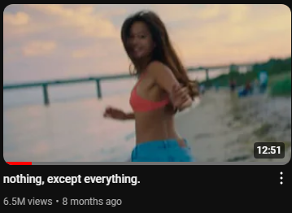

<https://www.youtube.com/watch?v=thpF81-wrMs>

Use of flip clock app in phone. Or make similar animation using after effects.

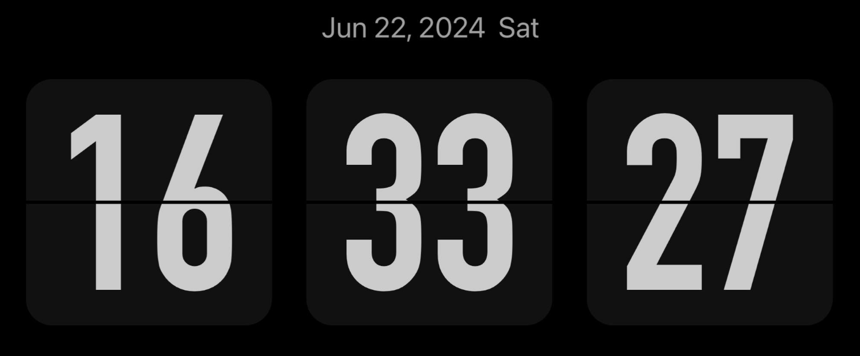

Playing with the colours.

Morning uthda chai black and white.

Ani every action he does makes him colorful part by part.

<https://www.tiktok.com/@vidsbykody/video/7377063682464959787>

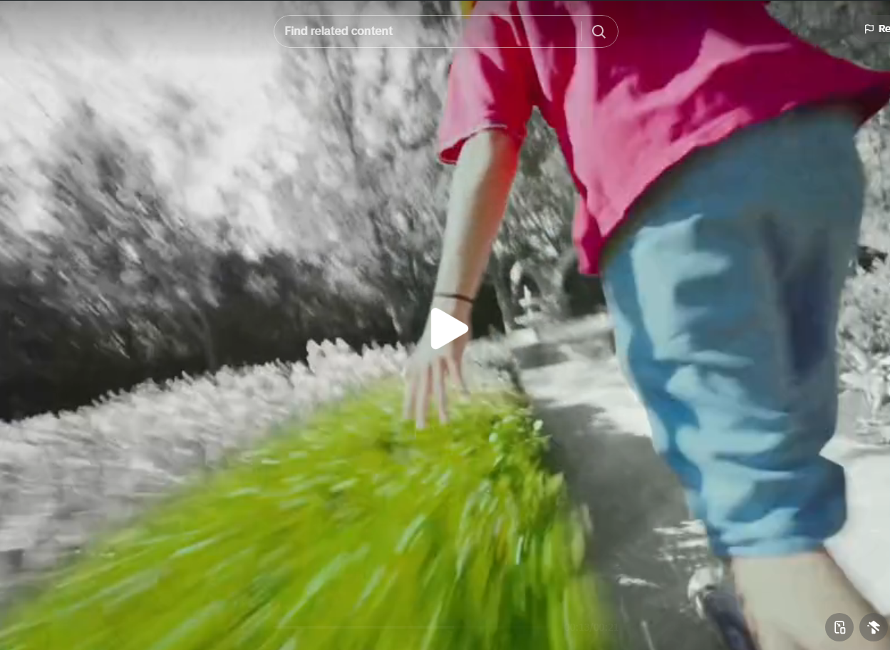

Now how can I implement this into the short film.

Rahul is getting ready to dive into the pool. (Rahul is colorful, but everything else isn’t. )

Rahul will dive into the pool and colors gradually fills the pool.

Wake up,

Tea banako raw khako

Sideways telephoto jogging, / drone shot.

Swimming, drone shot

Work, laptop.

Bathing shot.

Dhoka ma bell bajcha,

Chiya deliver huncha

Ani everything back to colourful.